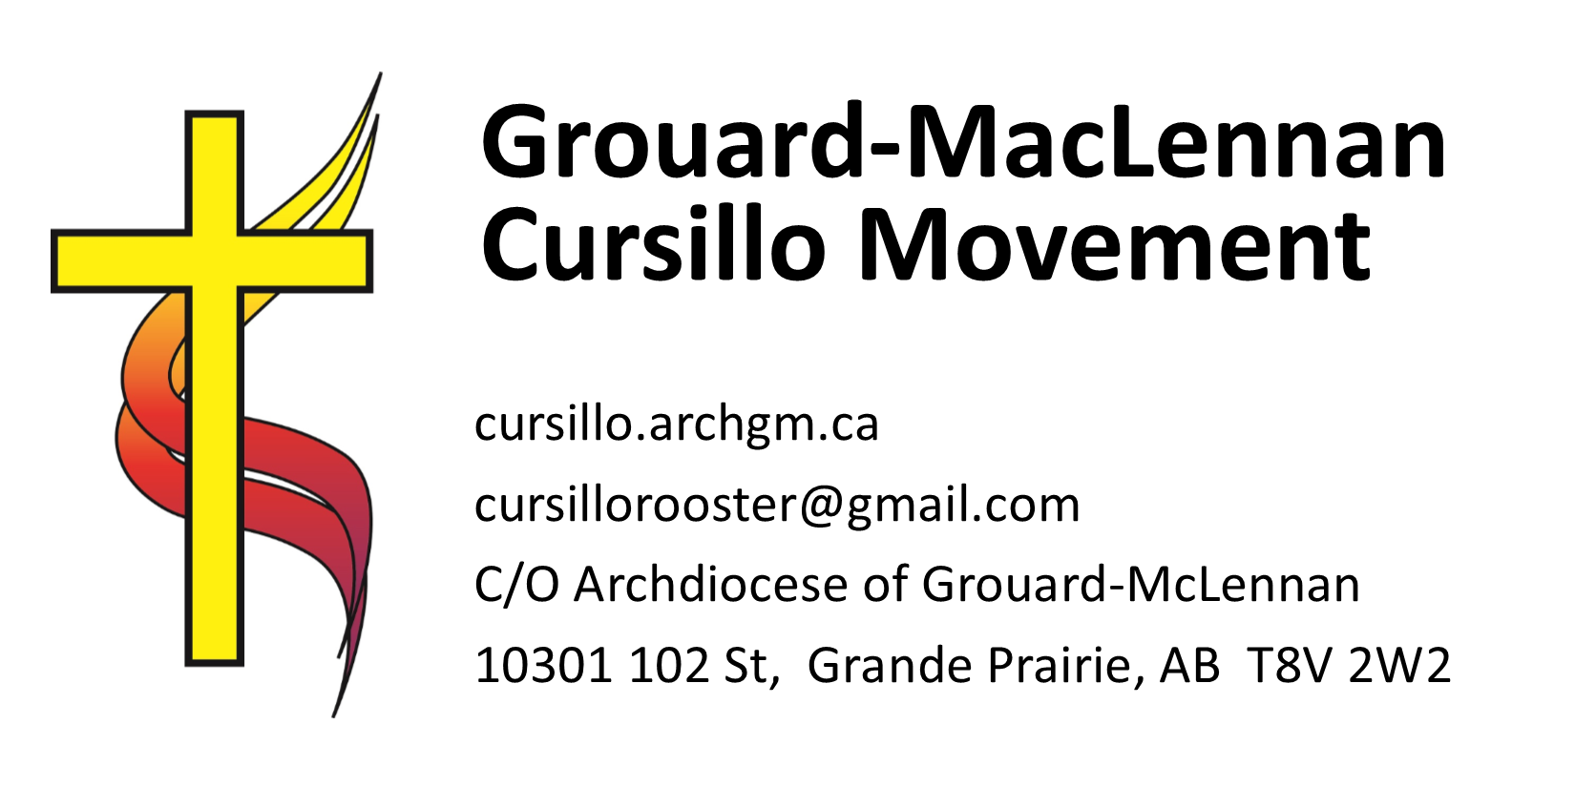
Grouard-McLennan Cursillo

Application for a Cursillo Weekend

Sponsoring a person for a Cursillo weekend is an act of love and responsibility. You are committing yourself to several obligations, both before, during and after the weekend. Please complete both parts of the attached application form.

Before approaching your friend about a Cursillo weekend, pray and ask the Holy Spirit to guide you regarding whether this is the right step for your friend to take in their faith journey.

To be a sponsor, you MUST:
- Have made a Cursillo weekend yourself
- Know the aim of the Cursillo movement
- Be an authentic witness of Christian Living
- Be ready to support your friend:
prior to the Cursillo, both socially and spiritually
during the weekend (mananitas, closing mass)
after the weekend (accompany them to several Ultreyas, invite them to your Group Reunion or help them start their own group reunion).

Points to Consider:
The purpose of Cursillo is to help individuals know that God loves them, inspiring them to become Christian leaders in their environments and transforming them in Christ. The weekend experience will be different for each candidate.
- The candidate must have self discipline and be of stable character
- They must be capable of understanding and living the Cursillo message
- They must be able to discover their gifts and put them at the service of the Christian Community.
- They must be capable of influencing others in their environments; they must be able to help others practically and spiritually.
- Attending Ultreyas and being part of a regular Group Reunion (or other small community) must be
a possibility.

There are some individuals for whom a Cursillo weekend may not be recommended:
- Anyone who is presently emotionally unstable
- Those who have serious, active addiction problems (drugs, alcohol, gambling)
- Those with extreme emotional conditions (nervous breakdown, clinical depression)
- One who is closed to the Christian perspective

It is imperative that your friend be properly prepared for the weekend and the post-Cursillo. They must be aware that this is not a purely theoretical course; that there will be sharing and discussion of life, faith, beliefs, the Church and issues connected to these. Cursillo has been described as an Encounter with Christ – you must ensure that your candidate understands and is prepared for such an encounter.

Grouard-McLennan Cursillo Sponsor Commitment and Endorsement
To be completed by the Sponsor

This form must be completed in full and returned with the Candidate Application Form to the Director
of Cursillo, at least four weeks prior to the weekend. Failure to complete both forms will jeopardize the opportunity for the candidate to be selected.

Director of Cursillo, C/O Archdiocese of Grouard McLennan, 10301 102 St. Grande Prairie, AB T8V 2W2 or
e-mail: cursillorooster@gmail.com

Candidate name:____________________________________________________________________
How long have you known this person? _________________________________________________
How do you know them? _____________________________________________________________
Have you explained the purpose of the Cursillo Weekend? _______________________
Why do you feel this person should attend a Cursillo Weekend? _____________________________
__________________________________________________________________________________
__________________________________________________________________________________
Do they have any physical, emotional or spiritual issues which would affect their ability to participate in the weekend? _________________________________________________________
__________________________________________________________________________________
Do they have alcohol or drug related problems? _________________________________
What specific arrangements have you made for your friend to join a group reunion?
__________________________________________________________________________________ Where and when did you make your Cursillo weekend? _____________________________________
Do you attend Ultreya? □Yes □ No Are you currently in a group reunion? □Yes □ No
If you are in a group reunion, would you consider accepting one or more new members? □Yes □ No
If you are not in a group reunion, are you part of another small community
that meets the intent of a reunion (eg. Bible Study, Prayer Group, etc?) □Yes □ No
If you are not in a group reunion or other small community, would you like to be? □Yes □ No
In what community (i.e. town, city) would you be able to meet for a group reunion? ______________
By signing this application form you are accepting responsibility to follow up and support your candidate before, during and after the Cursillo Weekend. You are reminded that the purpose of the Cursillo Movement is to develop in adult Christians a consciousness of their power and mission to become leaders in the work of Christian Renewal, and to sustain them as they provide Christian leaven in civic, social and economic life. This “Christianizing of Environments” is what the Cursillo Movement is all about.

Sponsor’s Name:_______________________________________ Date: ________________________
(please print)
Address: ___________________________________________________________________________
City:________________________________ Postal Code: ___________ Home Phone: _____________

Cell Phone (if any):________________________ Work Phone (if any):__________________________

e-mail address (if any):________________________________________________________________

Grouard-McLennan Cursillo Movement
Candidate Application Form

To be completed by the Candidate

Full Name: ________________________________________ Birth date: _______________________

Address: __________________________________________________________________________
City: ____________________________ Postal Code: ____________ Phone: ____________________

Cell Phone (if any):___________________________Work Phone:_____________________________

e-mail address (if any):_______________________________________________________________

Religion/Denomination:________________________ Current parish:_________________________

Occupation: ________________________________________________________________________

Marital Status: Married □ Single □ Widow/Widower □ Separated □
Divorced □ Common Law □ Clergy or Religious □
Spouse’s Name (if applicable): _________________________________________________________
Date and location of spouse’s Cursillo (if applicable): ______________________________________

Please indicate involvement in any parish/community activities eg.:

Marriage Encounter □ Parish Council □ K of C □ Youth □
Charismatic Renewal □ Prayer Group □ CWL □ RCIA □
Other: ____________________________________________________________________________

Do you suffer from any medical problems which might cause difficulty during the
Cursillo weekend or which require special diet or medical attention? Please specify:
__________________________________________________________________________________
__________________________________________________________________________________
This application must be submitted at least four weeks before the Cursillo, in order to be considered. You will be notified of acceptance approximately two weeks before the weekend. If you are unable to attend the weekend, you application will be returned to you and can be resubmitted for the next weekend.

Signature of Applicant: _______________________________ Date: __________________________

Sponsor (Print Name):________________________________ Phone:_________________________

Sponsor’s Address/email: _____________________________________________________________

